mid-1
- Explain ISO-OSI reference model along with responsibilities of each layer (C312.1:Analyze) 4M
A.) The OSI Reference Model:
ISO is a multinational body dedicated for the network communication. The ISO introduce a communication model OSI for transferring of information between 2 nodes sender and receiver based on intermediate nodes. The model is called the ISO-OSI(Open Systems Interconnection) Reference Model because it deals with connecting open systems—that is, systems that are open for communication with other systems.
- Principles:
1. Each layer should be created where a different level of abstraction is needed.
2. Each layer should perform well defined functions.
3. Each layer should define internationally standardized protocols.
4. Layer boundaries should be chosen to minimize the information flow across the interfaces.
5. The no .of layers should be appropriate for the requirements.
1. The Physical Layer: The physical layer is concerned with transmitting raw bits over a communication channel. The design issues have to do with making sure that when one side sends a 1 bit, it is received by the other side as a 1 bit, not as a 0 bit. It deals with the mechanical and electrical specifications of the interface and transmission medium. It also defines the procedures and functions that physical devices and interfaces have to perform for transmission to Occur.
Responsibilities of the Physical layer:
1.Representation of bits: The physical layer data consists of a stream of bits.
2.Data rate: The number of bits sends per each second in the physical layer.
3.Synchronization of bits: While transmitting no. of bits, the bit rate must be synchronized which means the sender and receiver maintains clock period time interval during data transmission the two clocks of both sender and receiver must be synchronized.
4.Physical topology: The physical topology defines how devices are connected to make a network. Devices can be connected by using a mesh topology, a star topology , a ring topology , a bus topology .
5.Transmission mode: The physical layer also defines the direction of communication between three devices: simplex, half-duplex, full-duplex.

2. The Data Link Layer: The main task of the data link layer is to transmitting a raw bit which is taken from network layer in the form of data units. While transmitting information if any errors occur from the network.It is solved by data link layer issues.

Responsibilities of the Data link layer:
1.Framing: The data link layer divides the stream of bits received from the network layer into data units called frames.
2.Physical addressing: If frames are to be distributed to different systems on the network, the data link layer adds a header to the frame to define the sender and receiver of the frame.
3.Flow control: The data link layer control mechanism to avoid overloading when the data rate of receiver is less than sender.
4.Error control: The data link layer adds reliability to the physical layer by adding mechanisms to detect and retransmit damaged or lost frames. It also uses a mechanism to recognize duplicate frames. Error control is normally achieved through a trailer added to the end of the frame.
5.Access control: When two or more devices are connected to the same link, data link layer protocols are necessary to determine which device has control over the link at any given time.
3. Network Layer: The network layer is responsible for transmitting of packets from source to destination. The network layer ensures that each packet gets information from its source and it directly attached to destination point.
Responsibilities of the Network layer:
1.Logical addressing: The network layer defines addressing while packets are transfer across communication link we add header to the packet which contains information about source and destination.
2.Routing: Selection of best communication path way to reach destination based on different techniques.
4. The Transport Layer: The transport layer is responsible for process-to-process delivery of the entire message. Here process means an application running continuously.
Responsibilities of the Transport layer:
1.Service-point addressing: Computers often run several programs at the same time. For this reason, source-to-destination delivery means delivery not only from one computer to the next but also from a specific process (running program) on one computer to a specific process (running program) on the other. The transport layer header must therefore include a type of address called a service-pointaddress (or port address).
2.Segmentation and reassembly: A message is divided into transmittable segments, with each segment containing a sequence number. These numbers enable the transport layer to reassemble the message correctly upon arriving at the destination and to identify and replace packets that were lost in transmission.
3.Connection control: The transport layer can be either connectionless or connection oriented. A connectionless transport layer treats each segment as an independent packet and delivers it to the transport layer at the destination machine. A connection oriented transport layer makes a connection with the transport layer at the destination machine first before delivering the packets. After all the data are transferred, the connection is terminated.
4.Flow control: Like the data link layer, the transport layer is responsible for flow control. However, flow control at this layer is performed end to end rather than across a single link.
5.Error control: Like the data link layer, the transport layer is responsible for error control. However, error control at this layer is performed process-to-process rather than across a single link. The sending transport layer makes sure that the entire message arrives at the receiving transport layer without error (damage, loss, or duplication). Error correction is usually achieved through retransmission.
5.The Session Layer: The services provided by the first three layers (physical, data link, and network) are not sufficient for some processes. The session layer is the network dialog controller. It establishes, maintains, and synchronizes the interaction among communicating systems.

Responsibilities of the session layer:
1.Dialog control or Session control: The session layer allows two systems to enter into a dialog. It allows the communication between two processes to take place in either half duplex(one way at a time) or full-duplex (two ways at a time) mode.
2.Synchronization: It means adding check points while data is transmitting for the verification, if data is reached to destination or not. If a negative acknowledgement came from destination at any check point then sender retransmit that stream of data after completion of entire information.
6. PresentationLayer:The presentation layer is concerned with the syntax and semantics of the information exchanged between two systems. In order to make it possible for computers with different data representations to communicate, the data structures to be exchanged can be defined in an abstract way, along with a standard encoding to be used ''on the wire.''
Responsibilities of the Presentation Layer:
1.Translation: The processes (running programs) in two systems are usually exchanging information in the form of character strings, numbers, and so on. The information must be changed to bit streams before being transmitted.
2.Encryption: Encryption means that the sender transforms the original information to another form and sends the resulting message out over the network. Decryptionreverses the original process to transform the message back to its original form.
3.Compression: Data compression reduces the number of bits contained in the information. Data compression becomes particularly in the transmission of multimedia such as text, audio, and video.
8.Application LayerThe application layer enables the user, whether human or software, to access the network. It provides user interfaces and support for services such as electronic mail, remote file access and transfer, shared database management and other types of distributed information services. This is about the application layer.

Responsibilities by the application layer:
1.Network virtual terminal: A network virtual terminal is a software version of a physical terminal, and it allows a user to log on to a remote host. The user's computer talks to the software terminal which, in turn, talks to the host, and vice versa.
2.File transfer, access, and management: This application allows a user to access files in a remote host (to make changes or read data), to retrieve files from a remote computer for use in the local computer, and to manage or control files in a remote computer locally.
3.Mail services: This application provides the basis for e-mail forwarding and storage.
4.Directory services: This application provides distributed database sources and access for global information about various objects and services.

2.Explain Frame and Acknowledgment Lost using GO BACK-N sliding window protocol. Explain random Access using CSMA/CD(C312.2:Apply) 4M
A.)GOBACK-N ARQ:
To improve the efficiency of transmission (filling the pipe), multiple frames must be in transition while waiting for acknowledgment. In other words, we need to let more than one frame be outstanding to keep the channel busy while the sender is waiting for acknowledgment. The first is called Go-Back-N Automatic Repeat Request (the rationale for the name will become clear later). In this protocol we can send several frames before receiving acknowledgments; we keep a copy of these frames until the acknowledgments arrive.

Sequence Numbers

Frames from a sending station are numbered sequentially. However, because we need to include the sequence number of each frame in the header, we need to set a limit. If the header of the frame allows m bits for the sequence number, the sequence numbers range from 0 to 2m - 1. For example, if m is 4, the only sequence numbers are 0 through 15 inclusive. However, we can repeat the sequence. So the sequence numbers are
0, 1,2,3,4,5,6, 7,8,9, 10, 11, 12, 13, 14, 15,0, 1,2,3,4,5,6,7,8,9,10, 11, ...
In other words, the sequence numbers are modulo-2m
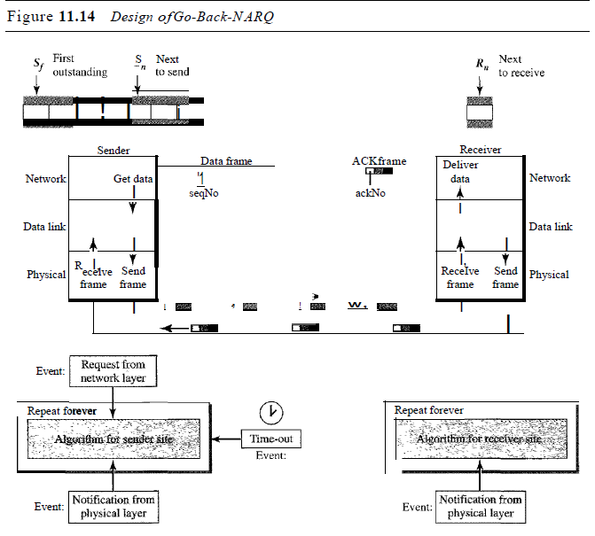
.
In the Go-Back-N Protocol, the sequence numbers are modulo 1!", where m is the size of the sequence number field in bits.

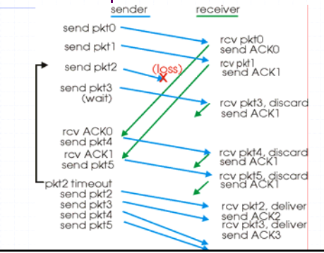
Carrier Sense Multiple Access (CSMA):

- To minimize the chance of collision and, therefore, increase the performance, the CSMA method was developed. The chance of collision can be reduced if a station senses the medium before trying to use it. Carrier sense multiple access (CSMA) requires that each station first listen to the medium (or check the state of the medium) before sending. In other words, CSMA is based on the principle "sense before transmit" or "listen before talk”

- CSMA can reduce the possibility of collision, but it cannot eliminate it. The reason for this is shown in Fig., At time t1 station B senses the medium and finds it idle, so it sends a frame. At time t2 (t2> t1) station C senses the medium and finds it idle because, at this time, the first bits from station B have not reached station C. Station C also sends a frame. The two signals collide and both frames are destroyed.
Persistence Methods:
It is the method of questioning. What should a station do if the channel is busy? What should a station do if the channel is idle?
There are 3 Methods:1. 1-persistent method
2. Non persistent method
3. p-persistent method
- 1-Persistent: The 1-persistent method is simple and straightforward. Inthis method, after the station finds the line idle, it sends its frame immediately (with probability I). This method has the highest chance of collision because two or more stations may find the line idle and send their frames immediately.
- Non persistent: Inthe non persistent method, a station that has a frame to send senses the line. If the line is idle, it sends immediately. If the line is not idle, it waits a random amount of time and then senses the line again. The non persistent approach reduces the chance of collision because it is unlikely that two or more stations will wait the same amount of time and retry to send simultaneously.
- P-Persistent: The p-persistent method is used if the channel has time slots with a slot duration equal to or greater than the maximum propagation time. The p-persistent approach combines the advantages of the other two strategies. It reduces the chance of collision and improves efficiency.

Carrier Sense Multiple Access with Collision Detection (CSMA/CD)
The CSMA method does not specify the procedure following a collision. Carrier sense multiple access with collision detection (CSMA/CD) augments the algorithm to handle the collision.
Procedure
- It is similar to the one for the ALOHA protocol, but there are differences. The first difference is the addition of the persistence process. We need to sense the channel before we start sending the frame by using one of the persistence processes we discussed previously (non persistent, 1-persistent, or p-persistent).
- The second difference is the frame transmission. In ALOHA, we first transmit the entire frame and then wait for an acknowledgment. In CSMA/CD, transmission and collision detection is a continuous process. We do not send the entire frame and then look for a collision. The station transmits and receives continuously and simultaneously
- If the station is idle it transmit the frame it shows a loop condition continuously if the transmission channel is idle
- When we come out of the loop, if a collision has not been detected, it means that transmission is complete; the entire frame is transmitted. Otherwise, a collision has occurred. The third difference is the sending of a short jamming signal that enforces the collision in case other stations have not yet sensed the collision.

Carrier Sense Multiple Access with Collision Avoidance (CSMA/CA)
In this the collisions are detected and avoided maximum through on 3 strategies
1. IFS [Inter Frame Space]
2. Content Window
3. Acknowledgement

- IFS [inter frame space]
In this for the transmission of frame before applying persistence method it will takes some amount of time to check it is called IFS
- Content window
If it is busy it doesn’t restart if the transmission line is idle then it starts sending of frame by defining frame size along with frame time slots.this is called content window.
- Acknowledgement
Based up on the context window time slot the frame sends and with in the time interval the acknowledgement is receive hence successful transmission take place. It is called Acknowledgement.
Procedure:The channel needs to be sensed before and after the IFS. The channel also needs to be sensed during the contention time. For each time slot of the contention window, the channel is sensed. If it is found idle, the timer continues; if the channel is found busy, the timer is stopped and continues after the timer becomes idle again.

- What is an Ethernet and its categories. Perform Error Detection method using CRC(C312.3:Analyze) 2M
A.)Ethernet:-
It is a LAN network which uses CSMA/CD.it is defined by IEEE 802.3 .
Categories:-
It is of 4 categories
1.standard Ethernet:- it defines the wide LAN connection by specifying minimum channel allocation. It defines in MAC sublayer with frame format and physical layer with four types of implementations.
2.fast Ethernet:- This type of Ethernet is usually supported by a twisted pair or CAT5 cable, which has the potential to transfer or receive data at around100 Mbps.
3.Gigabite Ethernet:- This type of Ethernet network is an upgrade from Fast Ethernet, which uses fiber optic cable and twisted pair cable to create communication.
4.10Gigabite Ethernet:- This type of network can transmit data at a rate of 10 Gigabit/second, considered a more advanced and high-speed network.

Crc generator and checker:
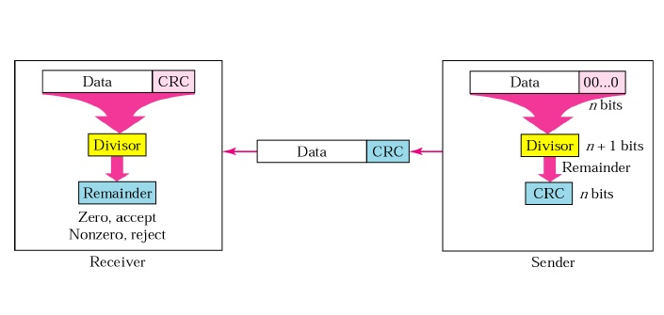
Binary division in Crc generator:

Mid-2

1.Explain 802.11 Frame format and Architecture (C312.3 Analyze) 2M
A.)IEEE 802.11:
IEEE 802.11 wireless LANs, sometimes called wireless Ethernet, and Bluetooth, a technology for small wireless LANs. Although both protocols need several layers to operate, we concentrate mostly on the physical and data link layers.
ARCHITECTURE: It consists of various components they are(STA), BSS, AP, the ESS,
and DS
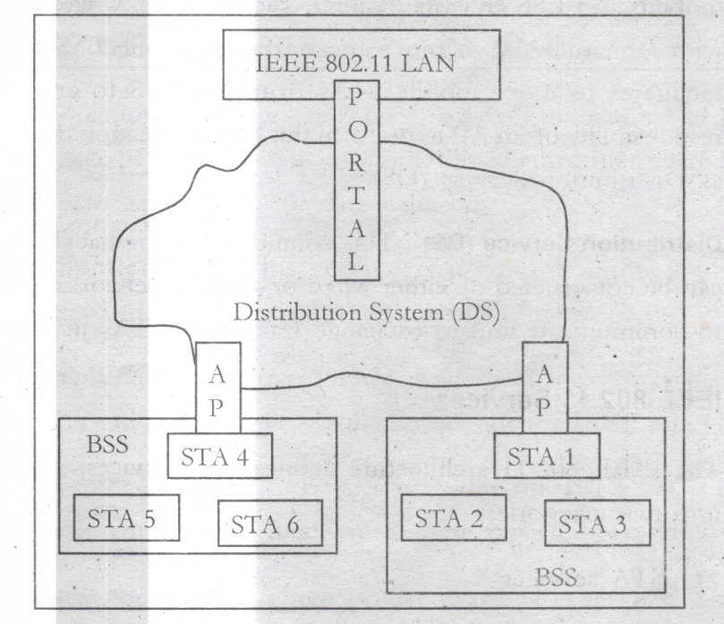

STA(Station):
A station may be a device it can be a mobile device or a network interface card (NIC) etc. The station must capable of transfer and receive data.
BSS(basic set service):
It is a specific location (or) it is a infrastructure which consists of set of devices which communicate with ech other.
ESS(extended set service): This component extends the range of mobility. It facilitates number of base stations with access points
AP (Access point): An Ap is just like a station just like a station it also provides the same services of STA. In BSS every mobile station communicates with AP. The function of AP is to provide both communication to the wired LAN for local function of BSS.
DS(Distributed Service): this component is the backbone of WLAN.It is a wireless lan which allows APS to exchange the data.
Frame Format:
- The 802.11 standard defines three different classes of frames on the wire: data, control, and management. Each of these has a header with a variety of fields used within the MAC sublayer.
- The format of the data frame .
- First comes the Frame Control field. It itself has 11 subfields.
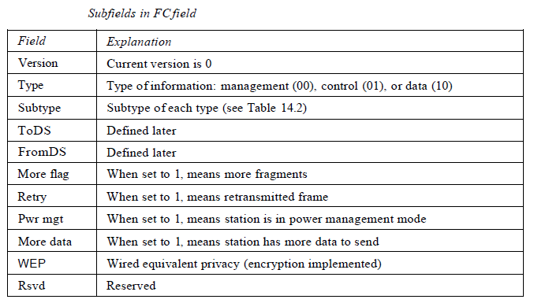
- The second field of the data frame, the Duration field, tells how long the frame and its acknowledgement will occupy the channel. This field is also present in the control frames and is how other stations manage the NAV mechanism.
- The frame header contains four addresses, all in standard IEEE 802 format. The source and destination are obviously needed, but what are the other two for? Remember that frames may enter or leave a cell via a base station.
- The other two addresses are used for the source and destination base stations for intercell traffic. The Sequence field allows fragments to be numbered. Of the 16 bits available, 12 identify the frame and 4 identify the fragment.
- The Data field contains the payload, up to 2312 bytes, followed by the usual Checksum. Management frames have a format similar to that of data frames, except without one of the base station addresses, because management frames are restricted to a single cell.
- Control frames are shorter still, having only one or two addresses, no Data field, and no Sequence field. The key information here is in the Subtype field, usually RTS, CTS, or ACK
Frame Types
- A wireless LAN defined by IEEE 802.11 has three categories of frames: management frames, control frames, and data frames.
- Management frames are used for the initial communication between stations and access points.
- Control frames are used for accessing the channel and acknowledging frames.

Case 1: 00 In this case, To DS = 0 and From DS = O. This means that the frame isnot going to a distribution system (To DS = 0) and is not coming from a distributionsystem (From DS =0). The frame is going from one station in a BSS to anotherwithout passing through the distribution system. The ACK frame should be sent tothe original sender.
Case 2: 01 In this case, To DS = 0 and From DS = 1. This means that the frame is coming from a distribution system (From DS = 1). The frame is coming from an AP and going to a station. The ACK should be sent to the AP. The addresses are as shown in Figure 14.9. Note that address 3 contains the original sender of the frame (in another BSS).
Case 3: 10 In this case, To DS =1 and From DS =O. This means that the frame is going to a distribution system (To DS = 1). The frame is going from a station to an AP. The ACK is sent to the original station. The addresses are as shown in Figure 14.9. Note that address 3 contains the final destination of the frame (in another BSS).
Case 4:11 In this case, To DS =1 and From DS =1. TIus is the case in which the distribution system is also wireless. The frame is going from one AP to anotherAP in a wireless distribution system. We do not need to define addresses if the distribution system is a wired LAN because the frame in these cases has the format of a wired LAN frame (Ethernet, for example). Here, we need four addresses to define the original sender, the final destination, and two intermediate APs.

2.Define Frame Format for IPV4. Explain Distance Vector Routing with an example (C314.Evaluate) 4M
A.)IPV4 Frame Format :
The Internet Protocol Version 4 (IPV4) is the delivery of mechanism used by TCP/IP protocols. Ipv4 is an unreliable and connectionless datagram protocol-a best-effort delivery service. The term best-effort means that IPV4 provides no error control or flow control. IPV4 assumes the unreliability of the underlying layers and does its best to get a transmission through to its destination, but with no guarantees. If reliability is important, IPV4 must be paired with a reliable protocol such as TCP. An example of a more commonly understood best-effort delivery service is the post office. IPV4 is also a connectionless protocol for a packet-switching network that uses the datagram approach.
Datagram:
Packets in the IPV4 layer are called datagrams.
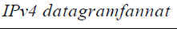
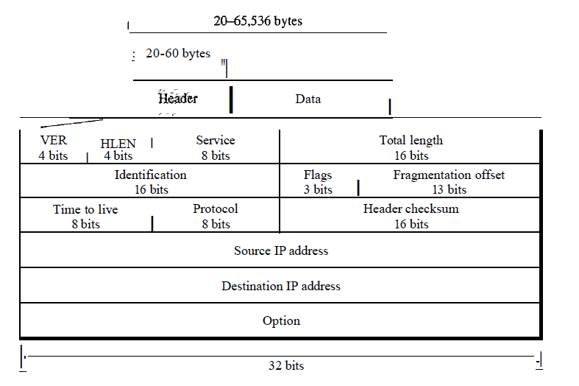
A datagram is a variable length packet consisting of two parts: Header and data.
The header is 20-60 bytes in length and contains information essential to routing and delivery. It is customary in TCP/IP to show the header in 4-byte sections. A brief description of each field is in order.
Version(VER): This 4-bit field defines the version of IPV4 protocol. Currently the version is 4. However version 6 may totally replace version4 in the future. This field tells the IPV4 software running in the processing machine that the datagram has the format of versionn4. All fields must be interpreted as specified in the fourth version of the protocol. If the machine is using some other version of IPV4, the datagram is discarded rather than interpreted incorrectly.
Header length(HLEN): This 4-bit field defines the total length of the datagram header in 4-byte words. This field is needed because the length of the header is variable(between 20 and 60 bytes). When there are no options, the header length is 20 bytes, and the value of this field is 5 (5*4=20). When the option field is at its maximum size, the value of this field is 15 (15*4=60) .
Services: IETF has changed the interpretation and name of this 8-bit field. This field, previously called service type, is now called differentiated services.
Total length: This is a 16 bit field that defines the total length (header plus data) of the IPV4 datagram in bytes. To find the length of the data coming from the upper layer, subtract the header length from the total length. The header length can be found by multiplying the value in the HLEN field by 4.
Identification: This field is used in fragmentation.
Flags: This field is used in fragmentation.
Fragmentation offset: This field is used in fragmentation.
Time to live: A datagram has a limited life time in its travel through an internet. This field was originally designed to hold a timestamp, which was decremented by each visited router. The datagram was discarded when the value becomes zero. However, for this scheme, all the machines must have synchronized clocks and must know how long it takes for a datagram to go from one machine to another. Today this field is used mostly to control the maximum number of hopes (routers) visited by the datagram. When a source host sends the datagram, it stores a number in this field. The value is approximately 2 times the maximum number of router between any 2 hosts. Each router that processes the datagram decrements this number by 1.If this value, after being decremented, is zero, the router discards the datagram.
Protocol: This 8-bit field defines the higher level protocol that uses the services of the IPV4 layer. An IPV4 datagram can encapsulate data from several higher level protocols such as TCP,UDP,ICMP and IGMP. This field specifies the final destination protocol to which the IPV4 datagram is delivered
Checksum: The checksum in the IP packet covers only the header, not the data. There are 2 good reasons for this. First, all higher level protocols that encapsulated data in the IP datagram have a checksum field that covers the whole packet.
Source address: This 32 bit field defines the IPV4 address of the source. This field must remain unchanged during the time the IPV4 datagram travels from the source host to destination host.
Destination address: This 32 bit field defines the IPV4 address of the destination. This field must remain unchanged during the time the IPV4 datagram travels from the source host to destination host.
- Distance Vector Routing:
- Distance vector routing algorithms operate by having each router maintain a table (i.e. a vector) giving the best known distance to each destination and which line to use to get there. These tables are updated by exchanging information with the neighbours.
- The distance vector routing algorithm is sometimes called by other names, most commonly the distributed Bellman-Ford routing algorithm and the Ford-Fulkerson algorithm; It was the original ARPANET routing algorithm and was also used in the Internet under the name IP.
- In distance vector routing, each router maintains a routing table indexed by, and containing one entry for, each router in the subnet. This entry contains two parts: the preferred outgoing line to use for that destination and an estimate of the time or distance to that destination. The metric used might be number of hops, time delay in milliseconds, total number of packets queued along the path, or something similar.
- As an example, assume that delay is used as a metric and that the router knows the delay to each of its neighbors. Once every T msec each router sends to each neighbor a list of its estimated delays to each destination. It also receives a similar list from each neighbor.
- Imagine that one of these tables has just come in from neighbor X, with Xi being X's estimate of how long it takes to get to router i. If the router knows that the delay to X is m msec, it also knows that it can reach router i via X in Xi + m msec. By performing this calculation for each neighbor, a router can find out which estimate seems the best and use that estimate and the corresponding line in its new routing table.
- Note that the old routing table is not used in the calculation. This updating process is illustrated in Fig. Part (a) shows a subnet. The first four columns of part (b) show the delay vectors received from the neighbors of router J. A claims to have a 12-msec delay to B, a 25-msec delay to C, a 40-msec delay to D, etc. Suppose that J has measured or estimated its delay to its neighbors, A, I, H, and K as 8, 10, 12, and 6 msec,
- For example Consider how J computes its new route to router G. It knows that it can get to A in 8 msec, an A claims to be able to get to G in 18 msec, so J knows it can count on a delay of 26 msec to G it forwards packets bound for G to A.
- Similarly, it computes the delay to G via I, H, and K as 4 (31 + 10), 18 (6 + 12), and 37 (31 + 6) msec, respectively. The best of these values is 18, so it makes an entry in its routing table that the delay to G is 18 msec and that the route to use is via H. The same calculation is performed for all the other destinations, with the new routing table shown in the figure
- New routing table for ‘J’ can be computed from its neighbors as follows:
- Similarly….the routing tables for J --> D,E,F,G,H,I,J,K, and L are computed.
New routing table for ‘J’:
Draw backs:
- It reacts… Rapidly to Good News
- Leisurely to Bad News

3.What is www.Explain the TCP Connection Establishment and Termination.(C312.5:Analyze) 4M

A.)World Wide Web:
- The World Wide Web (WWW), or the web, is a repository of information spread all over the world and linked together. The WWW has a unique combination of flexibility, portability and user-friendly features that distinguish it from other services provided by the Internet.
- The WWW project was initiated by CERN (European Laboratory for Particle Physics) to create a system to handle distributed resources necessary for scientific research. The WWW today is a distributed client-server service, in which a client using a browser can access a service using a server. However, the service provided is distributed over many locations called websites.
- The web consists of many web pages that incorporate text, graphics, sound, animation and other multimedia components. These web pages are connected to one another by hypertext. In a hypertext environment the information is stored using the concept of pointers.
- WWW uses a concept of HTTP which allows communicating between a web browser and web server. The web pages can be created by using a HTML (Hyper Text Markup Language). This language has some commands which are used to inform the browser about the way of displaying the text, graphics and multimedia files.
- HTML also has some commands through which we can give links to the web pages. If we want to get a page from the web, we have to type URL (Uniform Resource Locator) ‘for our desired page, or otherwise we have to click on a link that provides the URL.
- The URL specifies the internet address of the web server, the directory and name of our desired page. If there is no directory or web page specified, then the web server will provide a default home page.
- The WWW today is a distributed client-server service, in which a client using a browser can access a service using a server. Figure illustrates how the different web site can communicate with each other.
- Working of a Web:The Web operates on a client/server model. A web browser acts as the client in the WWW interaction. Using this program, a user sends a request for a web page stored on a web server. The web server locates this web page and sends it back, to the client computer. The web browser then interprets the web page

Connection Establishment:
TCP transmits data in full-duplex mode. When two TCPs in two machines are connected, they are able to send segments to each other simultaneously. This implies that each party must initialize communication and get approval from the other party before any data are transferred.
Three-Way Handshaking:
- The connection establishment in TCP is called threeway handshaking. In our example, an application program, called the client, wants to make a connection with another application program, called the server, using TCP as the transport layer protocol.
- The process starts with the server. The server program tells its TCP that it is ready to accept a connection. This is called a request for a passive open. Although the server TCP is ready to accept any connection from any machine in the world, it cannot make the connection itself.
- The client program issues a request for an active open. A client that wishes to connect to an open server tells its TCP that it needs to be connected to that particular server. TCP can now start the three-way handshaking process.

- To show the process, we use two time lines: one at each site. Each segment has values for all its header fields and perhaps for some of its option fields, too.
- However, we show only the few fields necessary to understand each phase. We show the sequence number, the acknowledgment number, the control flags (only those that are set), and the window size, if not empty. The three steps in this phase are as follows.

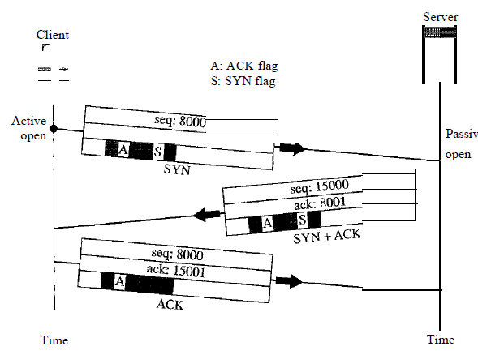

- The client sends the first segment, a SYN segment, in which only the SYN flag is set.
This segment is for synchronization of sequence numbers. It consumes one sequence number. When the data transfer starts, the sequence number is incremented by 1. We can say that the SYN segment carries no real data, but we can think of it as containing 1 imaginary byte. A SYN segment cannot carry data, but it consumes one sequence number.
2. The server sends the second segment, a SYN +ACK segment, with 2 flag bits set: SYN and ACK. This segment has a dual purpose. It is a SYN segment for communication in the other direction and serves as the acknowledgment for the SYN segment. It consumes one sequence number. A SYN +ACK segment cannot carry data, but does consume one sequence number.
3. The client sends the third segment. This is just an ACK segment. It acknowledges the receipt of the second segment with the ACK flag and acknowledgment number field. Note that the sequence number in this segment is the same as the one in the SYN segment; the ACK segment does not consume any sequence numbers. An ACK segment, if carrying no data, consumes no sequence number.
Connection Termination:
Any of the two parties involved in exchanging data (client or server) can close the connection, although it is usually initiated by the client. Most implementations today allow two options for connection termination: three-way handshaking and four-way handshaking
with a half-close option.
Three-Way Handshaking Most implementations today allow three-way handshaking
for connection termination.

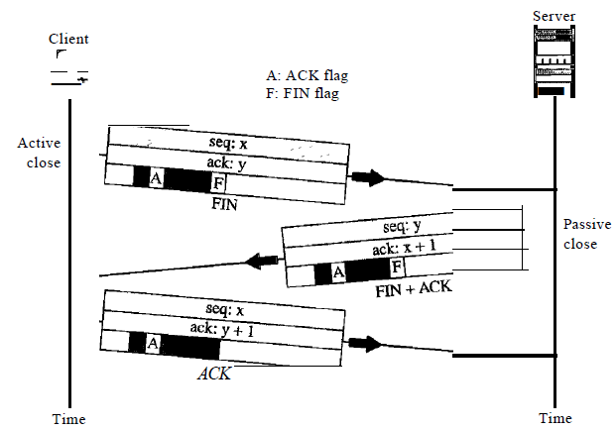
1. In a normal situation, the client TCP, after receiving a close command from the client process, sends the first segment, a FIN segment in which the FIN flag is set. The FIN segment consumes one sequence number ifit does not carry data.
2. The server TCP, after receiving the FIN segment, informs its process of the situation and sends the second segment, a FIN +ACK segment, to confirm the receipt of the FIN segment from the client and at the same time to announce the closing of the connection in the other direction. This segment can also contain the last chunk of data from the server. If it does not carry data, it consumes only one sequence number.
The FIN +ACK segment consumes one sequence number if it does not carry data.
3. The client TCP sends the last segment, an ACK segment, to confirm the receipt of the FIN segment from the TCP server. This segment contains the acknowledgment number, which is 1 plus the sequence number received in the FIN segment from the server. This segment cannot carry data and consumes no sequence numbers.

